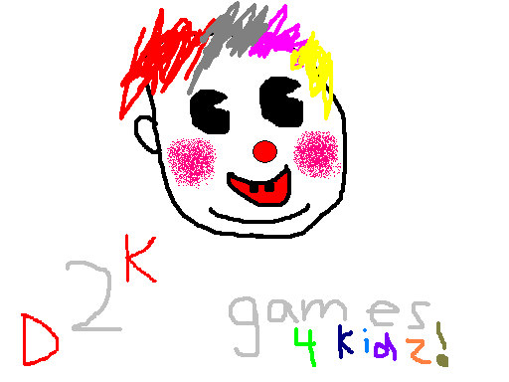
Proposed name of the game: Happy Clown: Laser Maze
_{D}2^{K} Games Studio (Jun Hee Cho & Calvin Chan)
Premise of the game (basic goal): Guide a laser and change its direction using a series of mirrors that are placed on the board. The goal is to make the laser reach an end point using the reflection.
Target audience (eg age/subject): 3-5 year olds only (educational game)
Basic rules:
The score is based on the time it takes to complete. A lower time is a better score.
There is no time limit or amount of tries.
Mirrors will be placed on the board beforehand. Clicking on them will rotate them.
Guide the laser to the end point successfully to complete the level.
Goal:
Teach children reflection physics with lasers (straight rays). This will also encourage the development of logic and problem solving skills through solving puzzles. This game also helps in the development of computer skills, such as the use of keyboard and mouse interfaces.

The client is entitled to:
A completed, original game that is functional
Weekly updates until the game is completed with a report
An executable CD with the game
An executable JAR file with the game

The client will agree to:
Acknowledge _{D}2^{K} Games Studio as the original authors of the game.
Not distribute, publish or publicly display the game without written permission from _{D}2^{K} Games Studio.
The game will not be sold for any form of currency without written permission from _{D}2^{K} Games Studio.

Program features:
The code will be written by _{D}2^{K} Games Studio and in Java.
The game will be unique and original.
Game will be graphical and attractive to small children.
Installation program will be included.
Executable file that runs game will be included, with splash screen.
At least three gaming levels will be in the game with different difficulty levels.
High score files and screen.
Error trapped menus
More than 2 distinct and different user input screens.
Generation of properly formatted high scores.
Two full menus (pause game).
Game rules included
Cannot crash in all circumstances.
Proper programming conventions with included comments and JavaDoc.
Versions with weekly updates
Java help file included
Interesting graphical design.
User friendly and easy to use GUI.
Full JavaDoc with index file.
CD with appropriate cover, game instructions and installation instructions.

Potential Improvements:
Different colored lasers to their respective end points
Dragging mirrors to the board instead of preplaced mirrors
Extra objects that have different features such as a refractive medium

I, the client, ________________, agree to all terms of this contract and will abide by them.

Signature: _______________________ Date: _________________________

I, the team representative of __________________, agree to all terms of this contract and will abide by them.

Signature: _______________________ Date: _________________________

